**Course Specialist Test 2 Year 12**

Student name: ________________ Teacher name: ________________

**Task type: Response**

**Time allowed for this task: ____40_______ mins**

**Number of questions: _____7______**

**Materials required:** Calculator with CAS capability (to be provided by the student)

Standard items: Pens (blue/black preferred), pencils (including coloured), sharpener, correction fluid/tape, eraser, ruler, highlighters

Special items: Drawing instruments, templates, notes on one unfolded sheet of   
A4 paper, and up to three calculators approved for use in the WACE examinations

**Marks available: _41_____ marks**

**Task weighting: _10___%**

**Formula sheet provided: Yes**

**Note: All part questions worth more than 2 marks require working to obtain full marks.**

Q1 (2, 2 & 3 = 7 marks) (3.2.1-3.2.3)

Consider the functions  and  .

1. State the natural domain and range of .
2. Does  exist over the natural domain of ? Explain.
3. State the rule and natural domain and range of .

Q2 (3, 3, 1 &2 = 9 marks) (3.2.4)

Consider the function  with domain  .

1. Sketch the inverse function on the axes below.

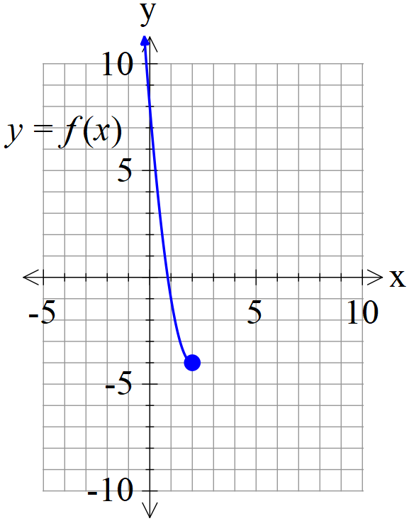

1. Determine the inverse function  stating its domain. (Show all working)
2. Determine 
3. Determine when  exactly.

Q3 (3 marks) (3.2.6)

Consider the inequality  is **only true** for  with  a constant.

Determine the value of .

Q4 (3 & 3 = 6 marks) (3.2.7)

Consider the following function .

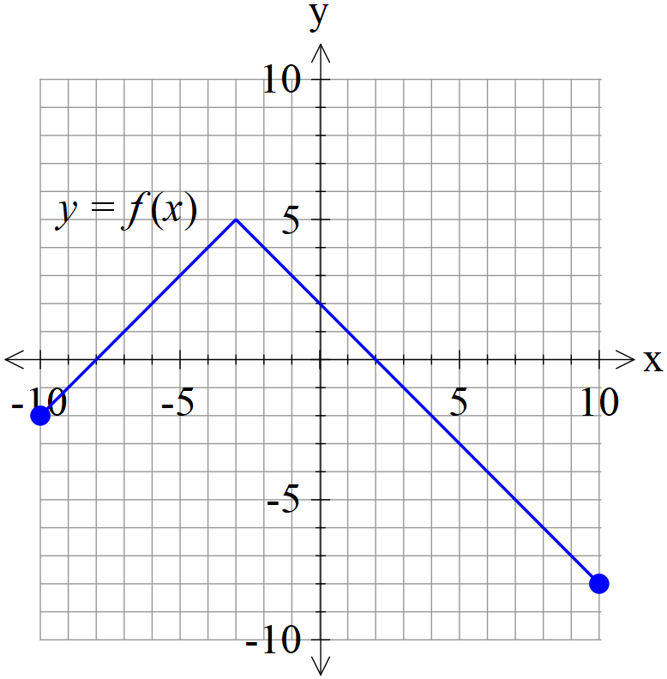

1. Sketch  on the axes below.

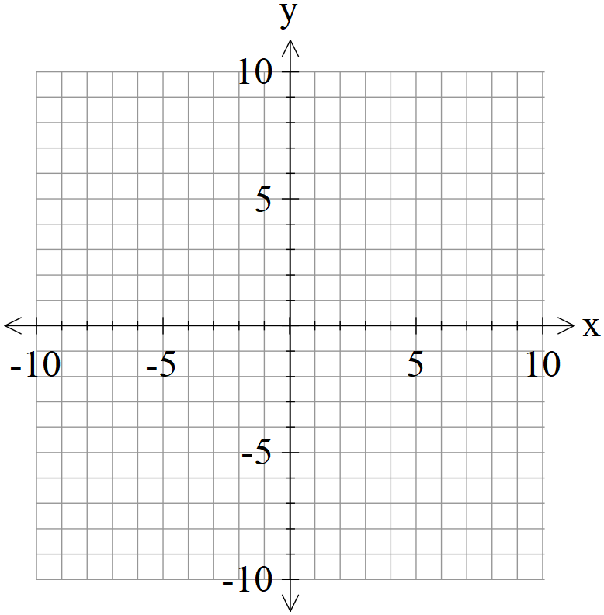

1. Sketch  on the axes below.

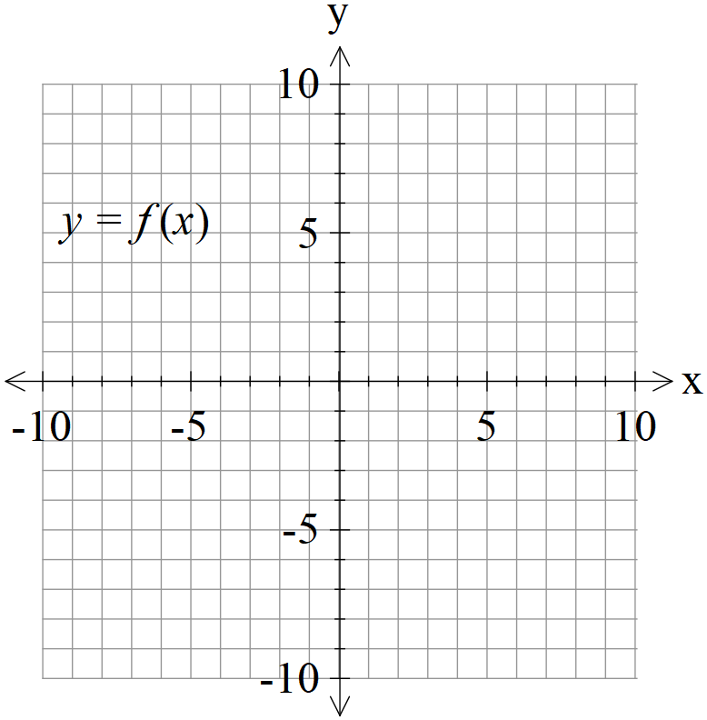

Q5 (3 & 3 = 6 marks) (3.3.3-3.3.6)

Consider two rockets A & B, moving with constant velocities such that at time  hours their positions and velocities are as follows:



1. Determine the time and distance of their closest approach.
2. Given that the rockets leave smoke trails that stay in the air for a long period of time, determine if the smoke trails cross at all and if they do, the point in space. Justify.

Q6 (6 marks) (3.3.4, 3.3.6)

Consider the line  and the sphere  with  a constant.

Determine the value(s) of , to one decimal place, such that:

1. The line is a tangent to sphere.
2. The line meets the sphere in two places.
3. The line misses the sphere completely.

Q7 (4 marks) (3.1.4)

The solutions to the complex equation  are plotted in the complex plane. ( is an integer &  is a complex constant). Exactly **four** of the solutions are plotted in the second quadrant,, and **no more**. Of these four solutions, the smallest argument is .

Determine all possible values of .